# 概论

## 啥是Android

* Android is the software platform from Google and the Open Handset Alliance that has the potential to revolutionize the global cell phone market.

Android 是一个专门针对移动设备的软件集，它包括一个操作系统，中间件和一些重要的应用程序。应用框架

## Android的特性

* Pro
  + Dalvik Virtual Machine
* Linux Kernel
  + Free
  + Stable
  + Driver support
* Framework
  + Java
  + Free Eclipse plugins
* Additional Features
  + Integrated(webkit) browser
  + 2D and 3D graphics APIs with HW
  + Database – SQLite
  + Video and audio codec
  + Bluetooth,EDGE,3G,Wifi
  + Camera, GPS, Compass, and accelerometer
* Con
  + No JVM
  + No J2ME
* Performance
  + Have to use JNI
* API
  + Android.*

## 设计理念

Iphone was designed by marketers and implemented by engineers

Android was designed by engineers and polished by the marketers

Openness

Always Connected

Customizable

## 最基本的And程序

XML——Layout

XML——Source

Java——Activity

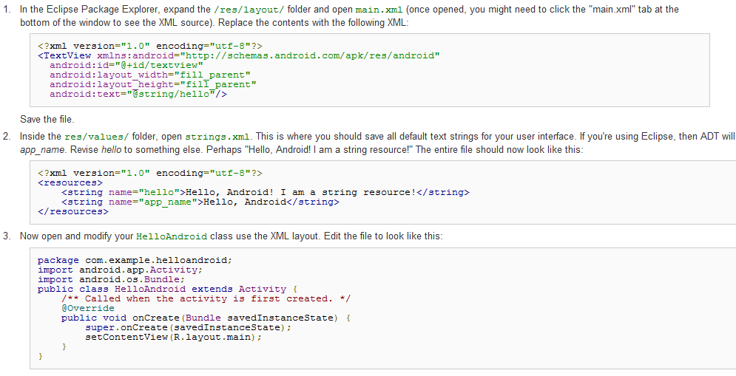

# 程序基础

## Linux Kernel

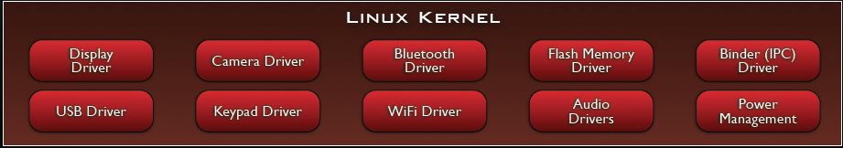

* + Ashmem——is a new shared memory allocator：10
  + Binder——corba-like IPC ：10
  + FrameBuffer——Driver for Display Equipment：29
  + Android Power Management

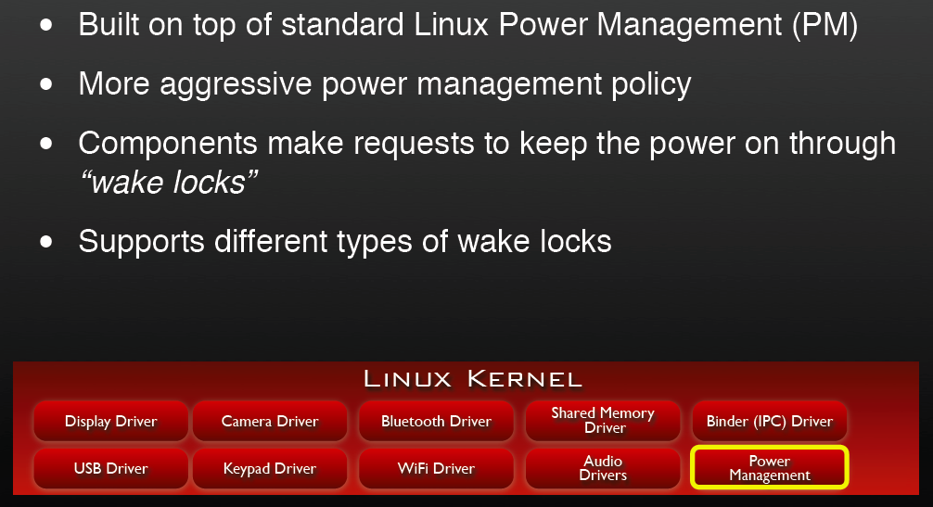

## Libraries

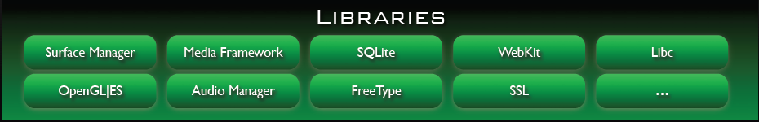

### Bionic Libc

* Custom C/C++ library implementation, optimized for embedded use.
* Not compatible with Gnu Libc (glibc)

### Function Libraries

**WebKit**

Based on open source WebKit browserFull CSS, Javascript, DOM, AJAX support

**Media Framework**

Based on PacketVideo OpenCORE platformSupports standard video, audio, still-frame formats

**SQLite**

Light-weight transactional data storeBack end for most platform data storage

### Surface Manager

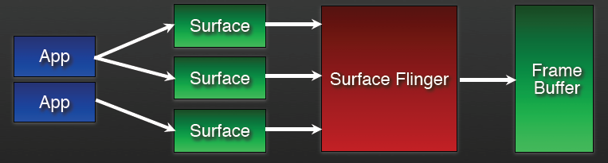

提供把各種”surface”組合在一起的能力。在這裡 surface 解釋為程式想要顯示在螢幕的東西，可能同一螢幕上有來自不同程式的內容，而這些內容有可能是 2D 顯示或是 3D 顯示等等之類。Surface flinger 就是把這些東西結合起來，一起送到螢幕上。

### Audio Manager

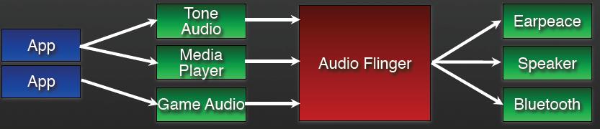

* Manages all audio output devices
* Handles audio routing to various outputs

## HardWare Adbstractoin Lib



* User space C/C++ library layer
* Defines the interface that Android requires hardware “drivers” to implement
* Separates the Android platform logic from the hardware interface
* Why do we need a user-space HAL?
  + Not all components have standardized kernel driver interfaces
  + Kernel drivers are GPL which exposes any proprietary IP
  + Android has specific requirements for hardware drivers

## Android RunTime

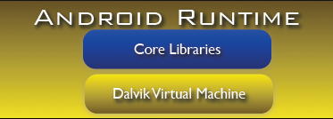

* Android custom implementation virtual machine
  + Provides application portability and runtime consistency
  + Runs optimized file format (.dex) and Dalvik bytecode
  + Java .class / .jar files converted to .dex at build time
* Designed for embedded environment
  + Supports multiple virtual machine processes per device
  + Highly CPU-optimized bytecode interpreter
  + Efficiently Using runtime memory
* Core Libraries
  + Core APIs for Java language provide a powerful, yet simple and familiar development platform

Android 虛擬機器與函式庫合稱 Android Runtime。它有幾個特性：

不能直接執行編譯好的 Java 程式。要轉換成 dex 檔案後才能執行。

若此程式使用了 Android 未提供的函式，仍不能執行。

若我們拿到了 Android 應用程式，無法在 Java Runtime 上跑起來。原因為 1. 必須把 dex 轉回 Java bytecode，這難度目前不明。2. 沒有 Android 提供的獨有函式。

## Application Framework

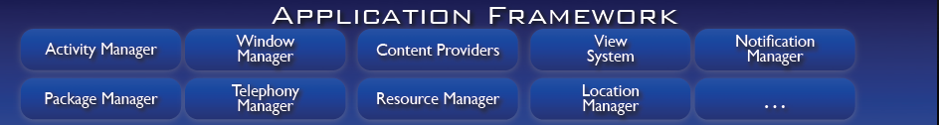

* Activity manager
  + Manage the life cycle of applications
* Content Provider
  + Share data between applications
* Resource Manager
  + Manager non-code resource
* Notification Manager
  + Display custom alerts in the status bar
* Views System
  + A rich and extensible set, which can construct UI

# Android 的启动

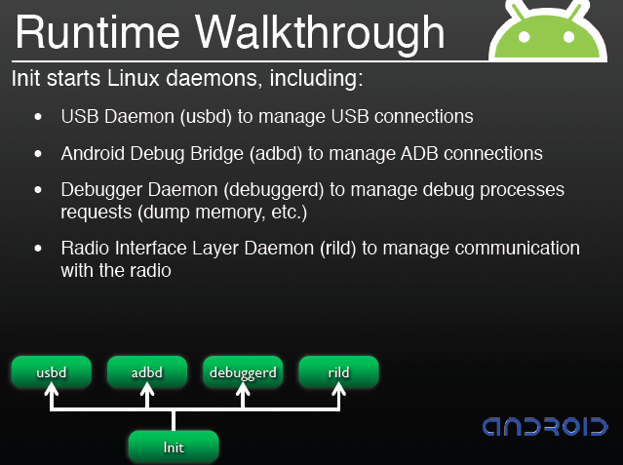

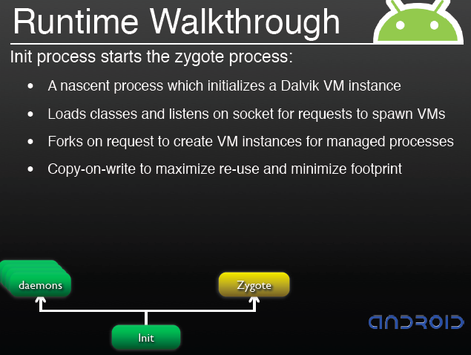

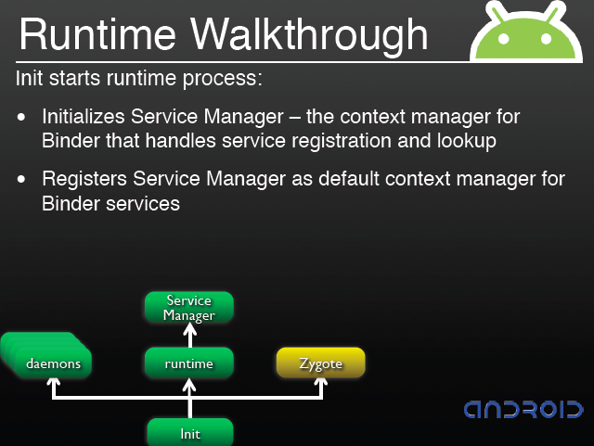

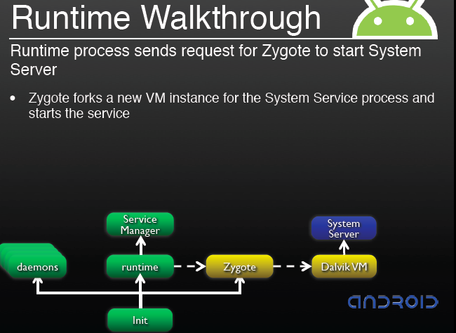

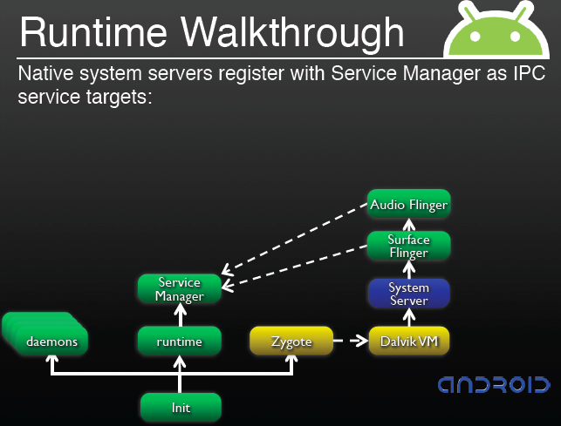

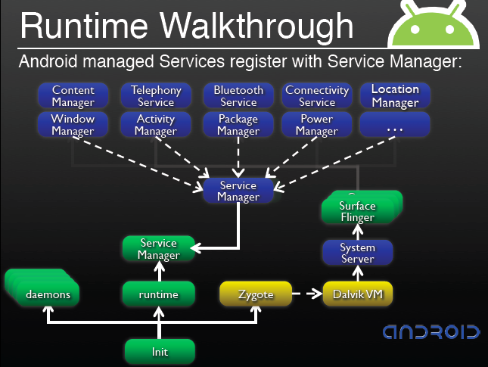

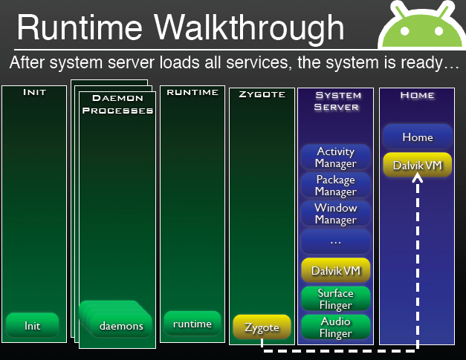

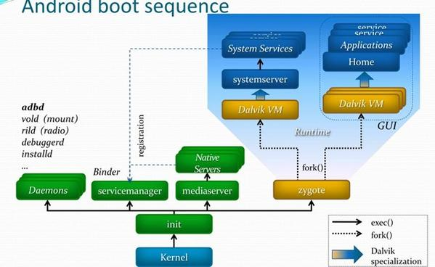

# Activity

* An Activity is an application component that provides a screen with which users can interact in order to do something,
* Each activity is given a window in which to draw its user interface

Declare the activity.

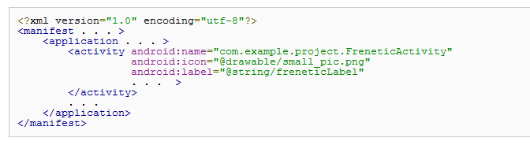

## 回调函数

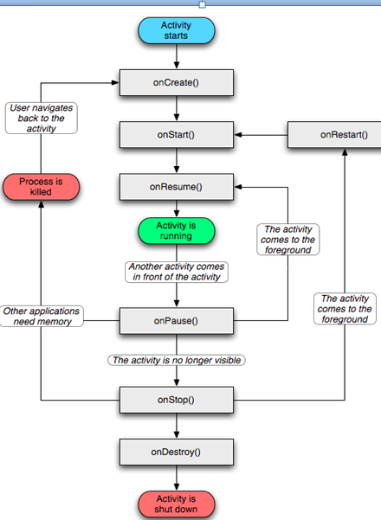

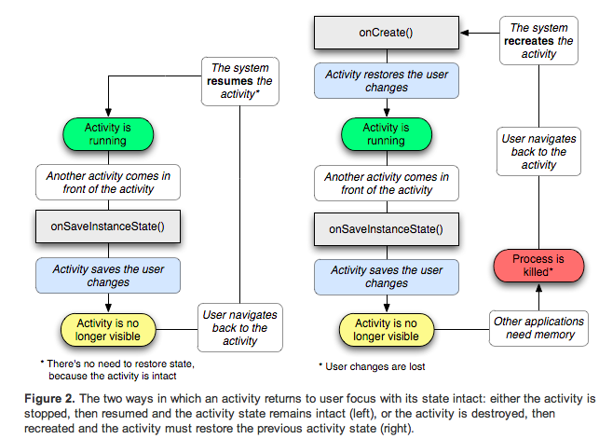

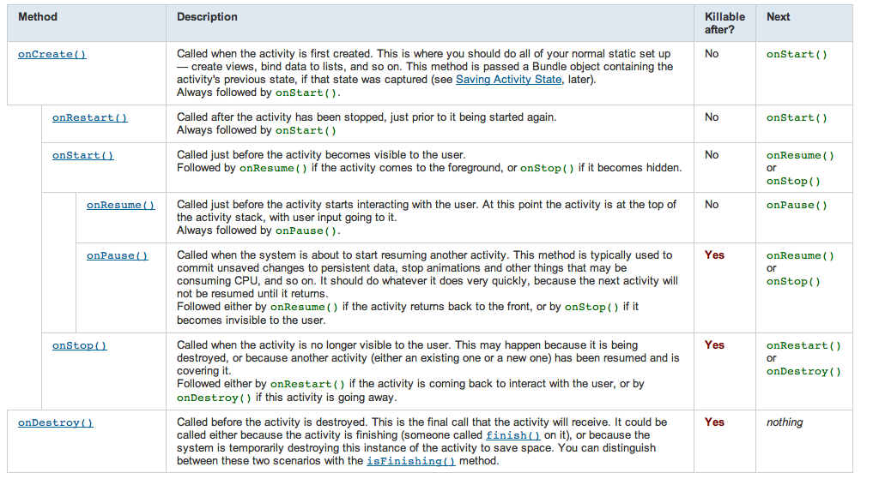

## Intent filters

* An Intent object can explicitly name a target component.
* If it does, Android finds that component (based on the declarations in the manifest file) and activates it.
* But if a target is not explicitly named, Android must locate the best component to respond to the intent.
* It does so by comparing the Intent object to the *intent filters* of potential targets.
* The intent specifies either the exact activity you want to start or describes the type of action you want to perform (and the system selects the appropriate activity for you, which can even be from a different application).

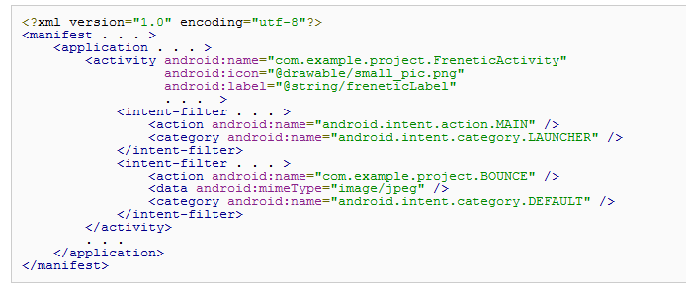

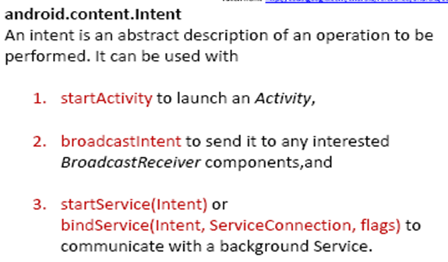

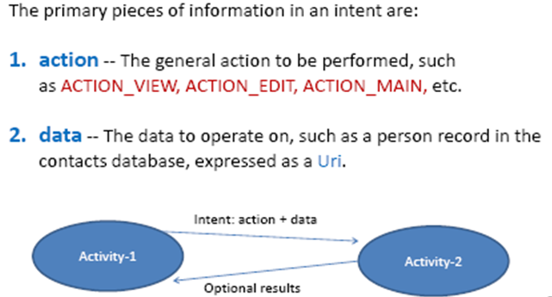

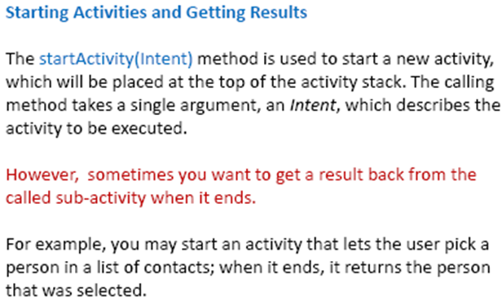

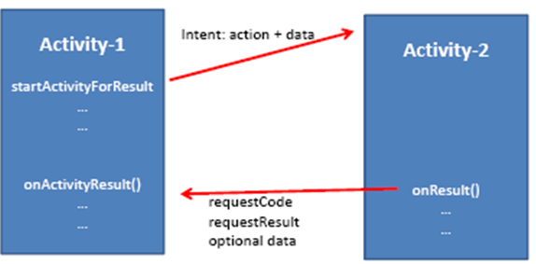

## Bundle

* The callback method in which you can save information about the current state of your activity is onSaveInstanceState(). The system calls this method before making the activity vulnerable to being destroyed and passes it a Bundle object.
* The Bundle is where you can store state information about the activity as name-value pairs, using methods such as putString().
* Then, if the system kills your activity's process and the user navigates back to your activity, the system passes the Bundle to onCreate() so you can restore the activity state you saved during onSaveInstanceState(). If there is no state information to restore, then the Bundle passed to onCreate() is null.

## Starting

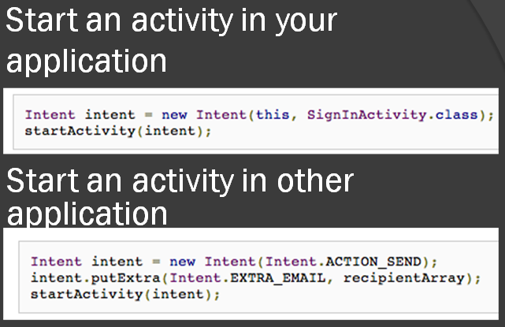

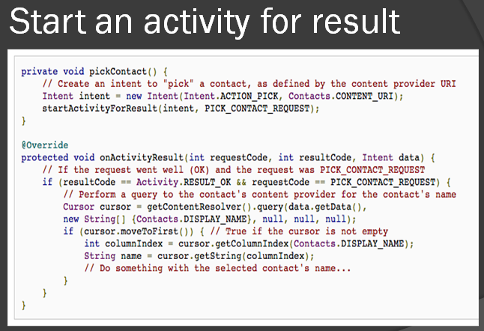

## Default

default implementation calls onSaveInstanceState()

* However, even if you do nothing and do not implement onSaveInstanceState(), some of the activity state is restored by the Activity class's default implementation of onSaveInstanceState().
* Specifically, the default implementation calls onSaveInstanceState() for every View in the layout, which allows each view to provide information about itself that should be saved.

Handling configuration changes

* Some device configurations can change during runtime (such as screen orientation, keyboard availability, and language).
* When such a change occurs, Android restarts the running Activity (onDestroy() is called, followed immediately by onCreate()).
* The restart behavior is designed to help your application adapt to new configurations by automatically reloading your application with alternative resources that you've provided.
* If you design your activity to properly handle this event, it will be more resilient to unexpected events in the activity lifecycle.

Coordinating activities

* The order of lifecycle callbacks is well defined, particularly when the two activities are in the same process and one is starting the other. Here's the order of operations that occur when Activity A starts Actvity B:
  + Activity A's onPause() method executes.
  + Activity B's onCreate(), onStart(), and onResume() methods execute in sequence. (Activity B now has user focus.)
  + Then, if Activity A is no longer visible on screen, its onStop() method executes.

## Back Stack

* Launch modes allow you to define how a new instance of an activity is associated with the current task. You can define different launch modes in two ways:
  + Using the manifest file
    - When you declare an activity in your manifest file, you can specify how the activity should associate with tasks when it starts.
  + Using Intent flags
    - When you call startActivity(), you can include a flag in the Intent that declares how (or whether) the new activity should associate with the current task.

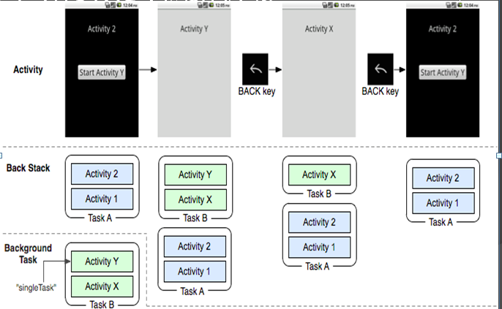

* Processes with the lowest importance are eliminated first, then those with the next lowest, and so on.
* There are five levels in the hierarchy.
  + Foreground process
  + Visible process
  + Service process
  + Background process
  + Empty process

# Fragment && Loader——3.0 ？不要看了吧。

## Fragment

## Loader

# Service

## 概论

* A service can be used in two ways:
  + It can be started and allowed to run until someone stops it or it stops itself.
  + It can be operated programmatically using an interface that it defines and exports. Clients establish a connection to the Service object and use that connection to call into the service.
* The two modes are not entirely separate. You can bind to a service that was started with startService().

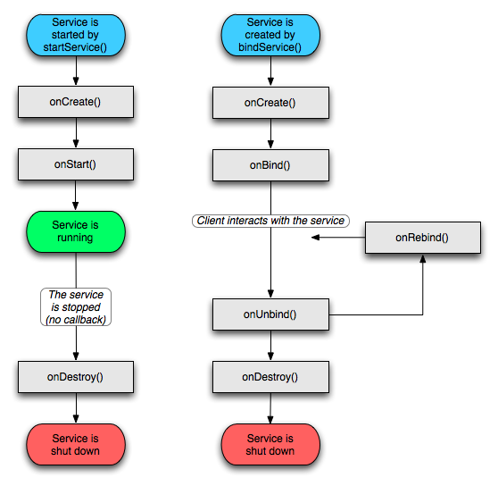

## Broadcast Receiver

* A *broadcast receiver is a component that does nothing but receive and react to broadcast announcements.*
* Many broadcasts originate in system code (eg. “you got mail“) but any other applications can also initiate broadcasts.
* *Broadcast receivers do not display a user interface. However, they may start an* activity in response to the information they receive, or ‐ as services do ‐ they may use the notification manager to alert the user.
* When a broadcast message arrives for the receiver, Android calls its [onReceive()](http://androidappdocs.appspot.com/reference/android/content/BroadcastReceiver.html) method and passes it the Intent object containing the message.
* The broadcast receiver is considered to be active only while it is executing this method. When onReceive() returns, it is inactive.

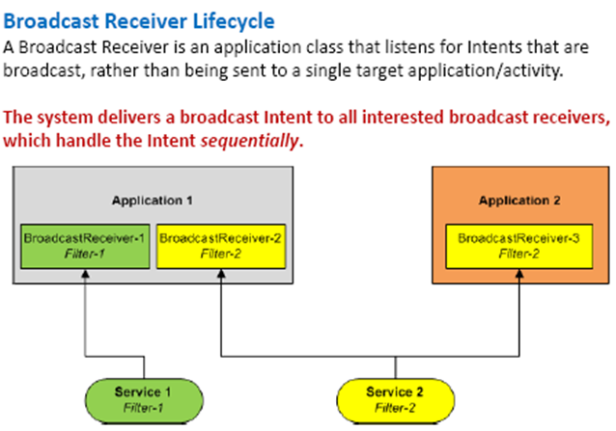

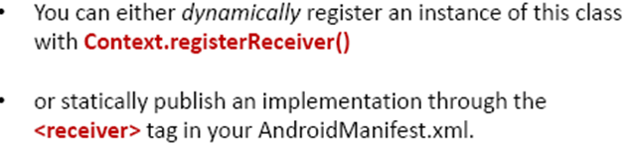

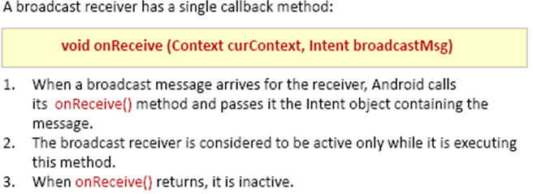

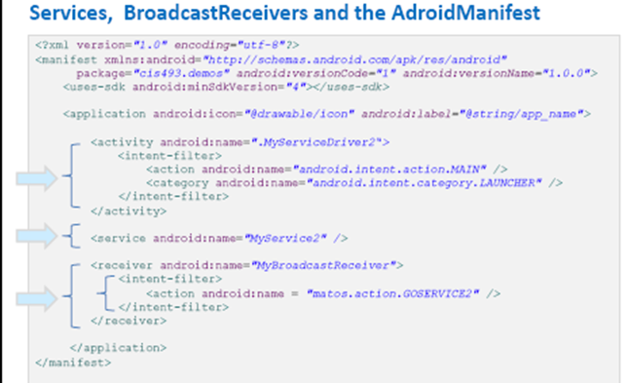

# UI

## 概论

## Layout

## Widget

## KeyBoard

## Menu

## WebKit

## Dialog

## 个性化控件

# HCI 设计

# 数据和存储

# 系统服务

## Content Provider

* A *content provider makes a specific set of the application's data available to* other applications.
* The data usually is stored in the file system, or in an SQLite database.
* The content provider implements a standard set of methods that enable other applications to retrieve and store data of the type it controls.
* However, applications do not call these methods directly. Rather they use a *content resolver object and call its methods instead. A content resolver can talk* to any content provider; it cooperates with the provider to manage any interprocess communication that's involved.

## Notification

# 高级话题

# 进阶内容

## 绘图

## 定位

## 传感器

## App Widget

## 网络访问

## 进程间通讯

# And软件开发

## And测试

## And 工程

## And最佳实践